The
Gospel of Mark

Faith is Simple

Whoever does the will of God is my brother and sister and mother.
3:35

And these are the ones sown on the good soil: they hear the word and accept it and bear good fruit ...
4:20

Whoever is not against us is for us.
9:40

Truly I tell you, whoever does not receive the kingdom of God as a little child will never enter it.
10:15

Faith is Complex

If you have ears to hear, then hear!
4:9

Do you have eyes and fail to see? Do you have ears and fail to hear? And do you not remember?
8:18

Therefore, keep awake, for you do not know when the master of the house will come, in the evening or at midnight or at cockcrow or at dawn, or else he may find you asleep when he comes suddenly. And what I say to you I say to all: Keep awake.
13:35-37

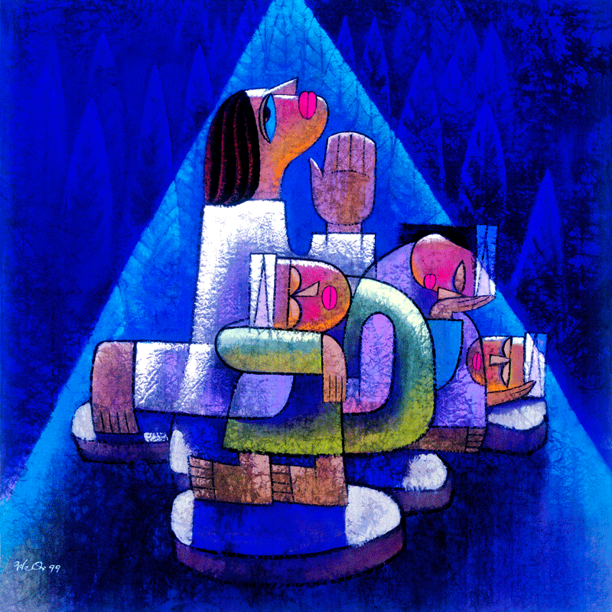

He Qi, “Praying-in-Gethsemane” (China, 1999) heqiart.com
Keep awake.
Mark 13:37

